ClassFlow (Basic account setup)

1. Open your browser to <www.classflow.com> (Chrome or Firefox)
2. Click Log in –Log in as teacher
   1. 
   2. Sign up with Microsoft account
   3. 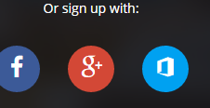
   4. Click on the Microsoft Icon
   5. 
   6. If the pop-up blocker notice comes, click always allow and then hit the link.
   7. Repeat steps a & b.
   8. 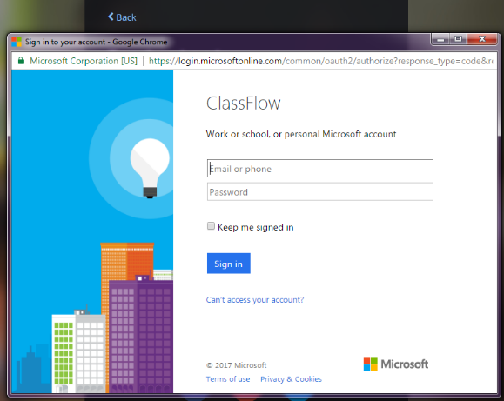
   9. Sign into your account with user name without boe. For example [jonesfr@richmond.k12.ga.us](mailto:jonesfr@richmond.k12.ga.us)
   10. Get started and explore!

